# Palestine: Femicide highlights need for domestic violence law

*The killing of a 30-year-old mother in occupied Ramallah by her husband has caused an uproar among Palestinians.*

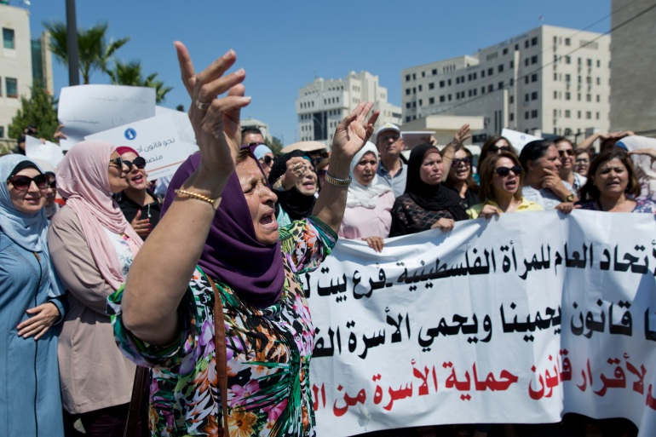

Palestinian women hold a banner that reads "Palestinian Woman's General Union, we need a law to protect us and to protect the Palestinian family" during a rally in front of the Prime Minister's office, in Ramallah in 2019

# Infographic: How Omicron compares with other COVID variants

*WHO says preliminary evidence indicates an ‘increased risk of reinfection with Omicron’ compared with other coronavirus variants, but information is limited.*



(Al Jazeera)

**By**[**Mohammed Haddad**](https://www.aljazeera.com/author/mohammed_haddad_201131616430386826)

Published On 29 Nov 2021

On November 24, 2021, scientists in South Africa reported a new coronavirus variant with a higher number of mutations than were found in other variants. Two days later, the World Health Organization (WHO) said the new variant, dubbed Omicron, was a variant of concern (VOC).

The announcement led many countries to impose

# Amazon deforestation is rising. Guyana offers a rare bright spot

*Trees cover 90 percent of land in Guyana, a country experts say can offer insights into protecting the world’s largest rainforest.*

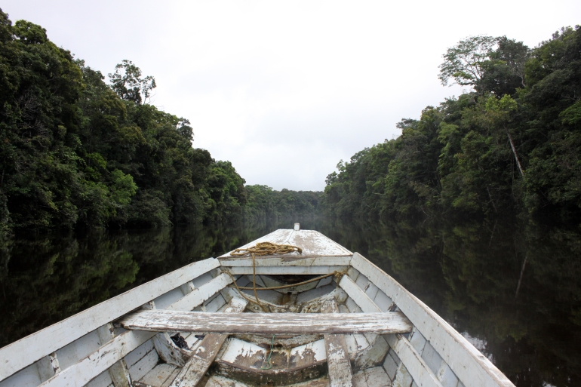

Guyana has maintained more than 80 percent of its humid forests, according to scientists, compared with less than 50 percent in other South American nations [File: Rustom Seegopaul/Al Jazeera]

**By**[**Chris Arsenault**](https://www.aljazeera.com/author/arsenaultc)

Published On 29 Nov 2021

This story was produced in partnership with the Pulitzer Center on Crisis Reporting.

**Georgetown, Guyana –** The only English-speaking nation in South America has one of the continent’s best track records for Amazon [rainforest protection](https://www.aljazeera.com/news/2021/6/11/deforestation-in-brazil-amazon-rainforest-soars-67-percent) – and an ad hoc patrol group of Indigenous farmers, teachers, and hunters tracking loggers and wildcat miners is part of the reason why.

# Iran and world powers begin Vienna talks to restore nuclear deal

*Both sides have repeatedly questioned each other’s commitment heading into the highly consequential talks.*

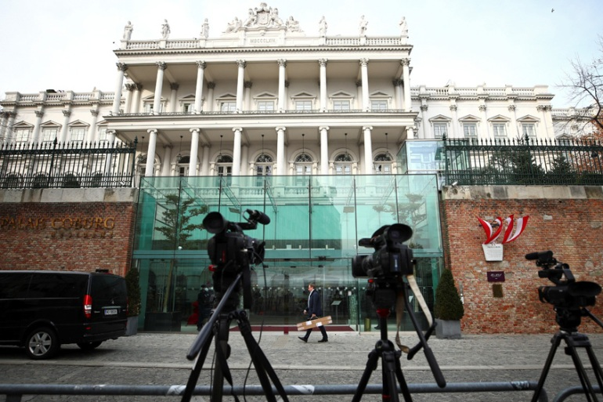

Cameras stand outside Palais Coburg, the site of a meeting of the Joint Comprehensive Plan of Action (JCPOA), in Vienna, Austria [Lisi Niesner/Reuters]

**By**[**Maziar Motamedi**](https://www.aljazeera.com/author/maziar_motamedi_190127060358086)

Published On 29 Nov 2021

**Tehran, Iran –** Iran and the world powers party to its 2015 nuclear deal have begun [long-awaited talks](https://www.aljazeera.com/news/2021/11/24/what-to-expect-as-iran-nuclear-talks-resume-next-week) in Vienna to restore the pact, which the United States abandoned three years ago.

Representatives of Iran, China, France, Germany, Russia, and the United Kingdom convened in the Austrian capital on Monday. Messages will be relayed to American representatives as Iran again refused to hold direct talks since the US is no longer a member of the accord.

[News](https://www.aljazeera.com/news/)|[Housing](https://www.aljazeera.com/tag/housing/)

# In tiny home villages, unhoused Americans find temporary reprieve

*A new pilot project in Oakland, California will allow unhoused people to co-govern their community.*

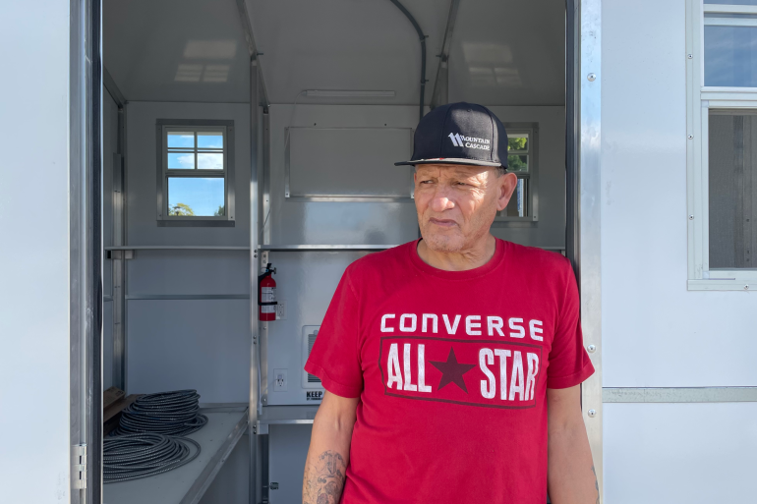

Tim Ybarra leans on the door frame of his shelter in the new community Union Point on the Rise in Oakland, California [Hilary Beaumont/Al Jazeera]

**By**[**Hilary Beaumont**](https://www.aljazeera.com/author/hilary_beaumont_191021110400406)

Published On 29 Nov 2021

**Oakland, California** – Tim Ybarra, 62, flips through an assembly book for a geodesic dome. It will ultimately become a kitchen, providing one meal a day for residents of Union Point on the Rise, a pilot project where unhoused people in the US city of Oakland will co-govern their community.

Surrounding Ybarra are 16 white, prefabricated tiny homes, purchased by the city for about $8,000 each. After living without a house for 15 years, and most recently in a tent, Ybarra is now moving into his new temporary home with a bed, electricity, heat, carbon monoxide monitor, fire alarm, fire extinguisher, and lock and key. He also has access to drinking water and a shower.

[LIVE](https://www.aljazeera.com/live)

**LIVE UPDATES**

[News](https://www.aljazeera.com/news/)|[Coronavirus pandemic](https://www.aljazeera.com/tag/coronavirus-pandemic/)

# South Africa wants Omicron travel ban lifted: Live

*South Africa’s health minister calls for lifting of ‘discriminatory’ travel bans imposed because of the Omicron variant.*

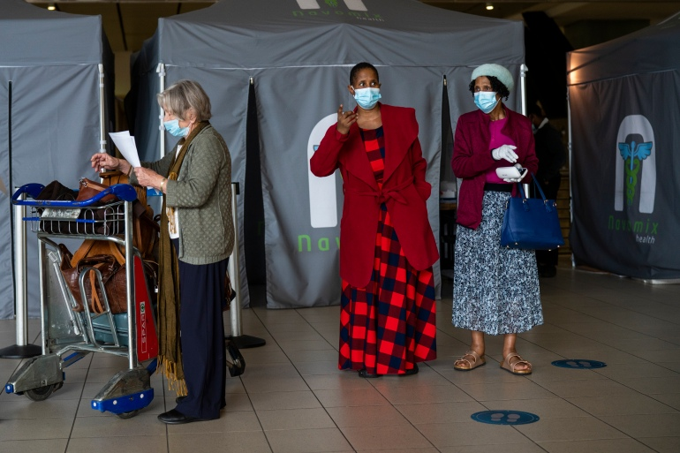

Passengers walk from a COVID -19 testing tent at Johannesburg's OR Tambo's airport Monday Nov. 29, 2021 [Jerome Delay/AP Photo]

**By**[**Federica Marsi**](https://www.aljazeera.com/author/marsif)**and**[**Usaid Siddiqui**](https://www.aljazeera.com/author/usaid_siddiqui_190806110228727)

Published On 29 Nov 2021

Updated:

12 minutes ago

A three-day special session of the World Health Assembly (WHA) has kicked off to discuss pandemic preparedness and response, amid concerns over the spread of the new [Omicron variant](https://www.aljazeera.com/program/inside-story/2021/11/27/how-worrying-is-the-new-omicron-coronavirus-variant).

The WHA normally meets in May but a special session was called for in a decision adopted by the World Health Organization member states.